Little SPARK: Simple Play Adaptations to Reference for Kids

Sensational Texture Activity Center
Description: | Image:
The Sensational Textured Activity Center includes mirrors, fans, music, songs, lights, sound effects, and spinning beads to offer a variety of textures, sights, and sounds that are activated by pressing one of six large activation plates each with a different texture and color.  Purchasing Information  User’s Manual | 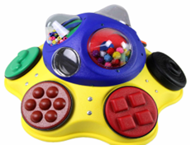

Who Might Benefit?
Those who experience difficulty manipulating small objects, have limited mobility for varied play positions, require development in reaching and hand-eye coordination, benefit from engaging visual and auditory materials to maintain attention, or have visual impairments that respond well to high-contrast objects.
Why Use?
Provides an opportunity to explore colors, textures, and sounds in one place, engage in directed reach and fine motor activities, and gain an understanding of simple cause and effect.
Instructions for Use: | Adaptation Ideas:
Environmental Considerations  - Use in any environment including community, home, and school.  Positioning  - Use in seated position at a table or on the floor, standing at a table, or lying on the floor.  - Place on a slanted surface to help with viewing and reaching.  Basic Play/Use  - Place in front of the child within easy reach for free exploration of the activation plates and activities to support cause and effect learning.  Extended Play/Use  - Use for specific actions (“push the button”), color activation (“push the blue button”), ask the child to name the color or describe the texture of the object.  Play/Use with Others  - Easily use with two or more children to play together either turn taking or engaged in parallel play. | Stabilize It  - Encourage the child to rest their forearm on the table while engaged in the activity.  - Use Dycem under the item or attach Velcro.  Simplify It  - Cover with a dark cloth to limit the number of choices available. Reveal one at a time for full exploration of each item separately or in any combination.  Add Sensory Cues  - Additional stickers, puffy paint, or other tactile cues.  Communication Support  - Communication boards to support the specific activity.  DIY Alternatives  - Build a toddler busy board with items you already have

Words to Encourage Play/Use
Push  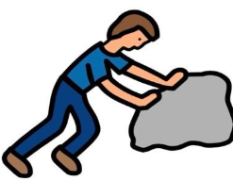 | Reach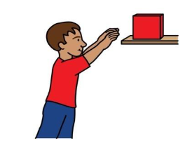 | Look  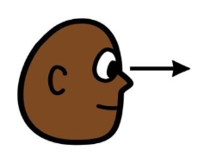
Help  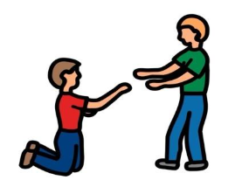 | Like   | Stop  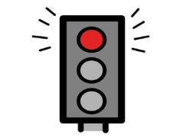
Go  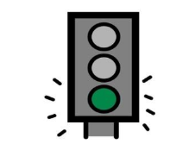 | More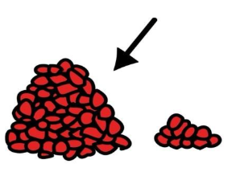 | Done  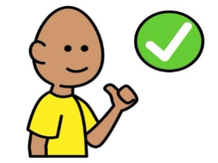
*”Adaptations” adapted from: Haugen’s Modes for Adapting Toys based on materials from the "Let's Play" Project at the University of Buffalo
PCS is a trademark of Tobii Dynavox, LLC. All rights reserved. Used with permission.

